Now I want to order by salary

Select \* from employee order by salary desc;

1. Create source
2. Create cast cast salary to integer
3. Click on + and select sort

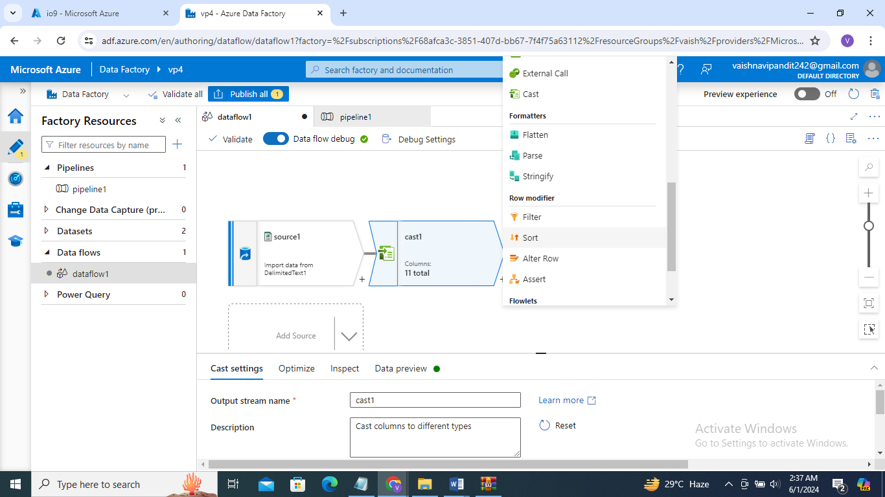

1. Now go to sort
2. In sort condition select column and ascending or descending

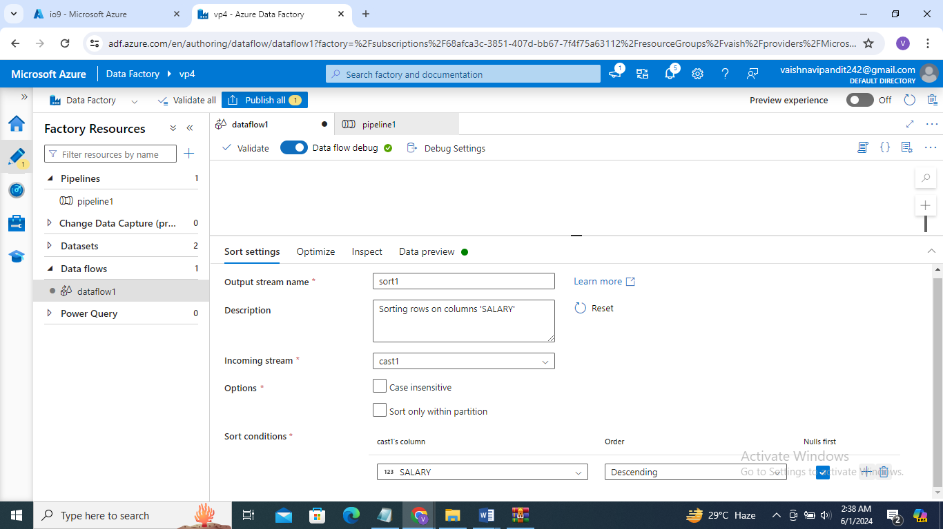

1. Done sink pipeline publish debug